July 21, 2026

Via Email

Doug Struyk
Blueline Realty Group LLC
426 Hudson St
Hackensack, NJ 07601

RE: Purchase Proposal – 24 Andrews Dr, Woodland Park, NJ - PavXpress

Dear Doug,

The purpose of this letter is to outline the general business terms and conditions under which Purchaser would acquire 24 Andrews Dr, Woodland Park, NJ and the outlined improvements (the “Project”).

- Property: 24 Andrews Dr, Woodland Park, New Jersey, Passaic County (Block 122, Lot 3.01). Approximately 4.7 acres in total, consisting of ±27,326 SF, single story industrial truck terminal facility with accompanying offices, car parking, trailer parking, drive paths, etc.

- Purchaser: PavXpress (please confirm), or affiliates/nominee.

- Seller: Please Confirm

- Purchase Price: $14,000,000

- Purchase Terms:

- Earnest Money: Within two business days following the date of full execution and delivery of the Purchase and Sale Agreement (the “PSA”), Purchaser will wire the sum of $200,000 into a joint order escrow account, which deposit shall be refundable to Purchaser unless the PSA is terminated due to a default by Purchaser.

- Financing: Purchaser intends to finance the purchase of the property.

- Seller (Tenant) Leaseback Terms:

Seller / Tenant: To Be Provided.; and/or an affiliated entity
Lease Term: 120 months
Lease Start Date: Upon close of title and the Lease Commencement Date (to be further addressed)
Leased Premises: 2.0 acres including a portion of the office space and two of the three maintenance bays. (See Exhibit A)
Starting Rent: $26,000 per acre per month NNN
Annual Escalations: 3.5%

- Contingencies: Purchaser’s obligation to close will be subject to the following:

- Investigation Period: The Purchaser shall have sixty (60) days after an executed contract and receipt of all plans, building specifications, leases, environmental documentation, service contracts, books, records, title documents, surveys, etc. relating to the Property to perform its due diligence. During the Investigation Period, Purchaser shall be permitted to obtain a Phase 1 Environmental Report and conduct soil borings, if deemed necessary.

The contract shall be conditional on Purchaser approving all matters at their sole discretion during the Investigation Period. If their findings are unsatisfactory or Purchaser has elected to terminate the contract during this period for any reason, all earnest money, together with any interest earned thereon, shall be returned to the Purchaser.

- Title and Survey: Seller shall deliver the Property with good and marketable title insurable by Purchaser’s title company at regular rates with no exceptions, other than those agreed to by Purchaser.

- Use Variance: Purchaser has confirmed with the municipality that a use variance is required to operate a trucking terminal at the Property. As such, purchaser will make reasonable efforts to obtain a use variance with the Sellers assistance as needed.

- Representations and Warranties: Seller’s representations and warranties shall be detailed in the PSA, including, but not limited to a representation and warranty the Property complies with all laws.

- Customary conditions to Closing: to be added in the PSA.

- Closing: The closing of the purchase and sale of the Project (the "Close of Escrow'') shall occur sixty (60) days following the satisfaction of all Contingencies and the expiration of the Investigation Period, or sooner if Purchaser provides waiver of same.

- Fees and Costs: Purchaser shall pay for (a) a survey, if so elected by Purchaser; (b) the costs for the standard title insurance policy and commercially reasonable endorsements; (c) recording fees for the deed. Seller shall be responsible for all transfer taxes, if any, and all recording charges to remove all liens, judgments, and other matters Seller is required to release under the PSA.

- Real Estate Taxes: All real estate taxes shall be prorated at closing.

- Real Estate Brokerage Commission: Seller agrees and acknowledges that Colliers (Purchaser Broker) represents the Purchaser in this transaction. Seller shall be responsible for payment of 3.75% commission of the sale price to Colliers at closing, to be memorialized under a separate written agreement between Seller and Colliers .

- Confidentiality: Purchaser and Seller shall hold in confidence all information relating to the terms of this transaction. Either party shall be permitted to share information internally and/or to advisors for purposes of the transaction, provided each party shall be responsible for the satisfaction of this obligation by their respective employees and advisors. Notwithstanding the foregoing, confidentiality shall not apply to any information or document which (a) was or becomes generally available to the public other than as a result of a disclosure in breach of this agreement, (b) was available to the receiving party on a nonconfidential basis before its disclosure by the other party to the receiving party, or (c) becomes available to the receiving party on a nonconfidential basis from an independent source, provided the receiving party was not aware such source was itself bound by an obligation of confidentiality.

- Exclusivity: During the sixty (60) day period following Seller’s acceptance of this letter and receipt of Security Deposit, Seller will not show, market, offer, or negotiate to sell the Properties or any portion thereof or interest therein to any party other than Purchaser, nor will Seller conduct discussions with any third party with respect to the same. Exclusivity shall survive through the Investigation Period. If the Purchaser terminates the contract, the Exclusivity will end.

- Purchase Agreement: After execution of this Letter of Intent, Seller will promptly deliver to Purchaser a form Purchase Agreement for its review and approval.

This letter of intent is meant to be an expression of the intent of the parties and no binding agreement shall exist between the parties unless and until the PSA is executed.

We look forward to hearing from you and will be happy to answer any questions you may have concerning the above proposal.

Sincerely,
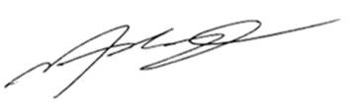
Noah Balanoff
Colliers International NJ LLC
Vice Chair | New Jersey

Cc: PavXpress

Agreed and Accepted:

By: ___________________________________________ By: ___________________________________________
(Seller) (Purchaser)

Date: _________________________________________ Date: _________________________________________

EXHIBIT A:
Darker shaded area represents the Seller (Tenant) Leaseback area. To be further addressed between Purchaser and Seller.
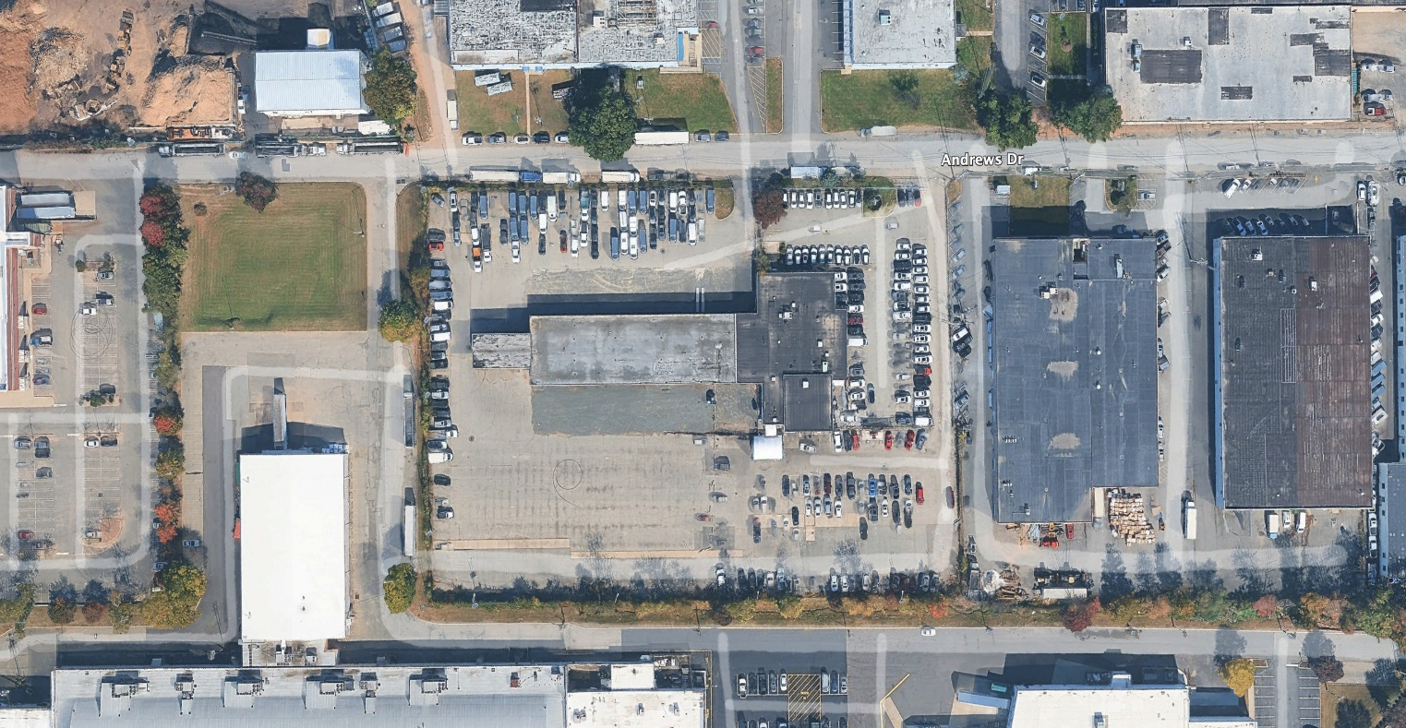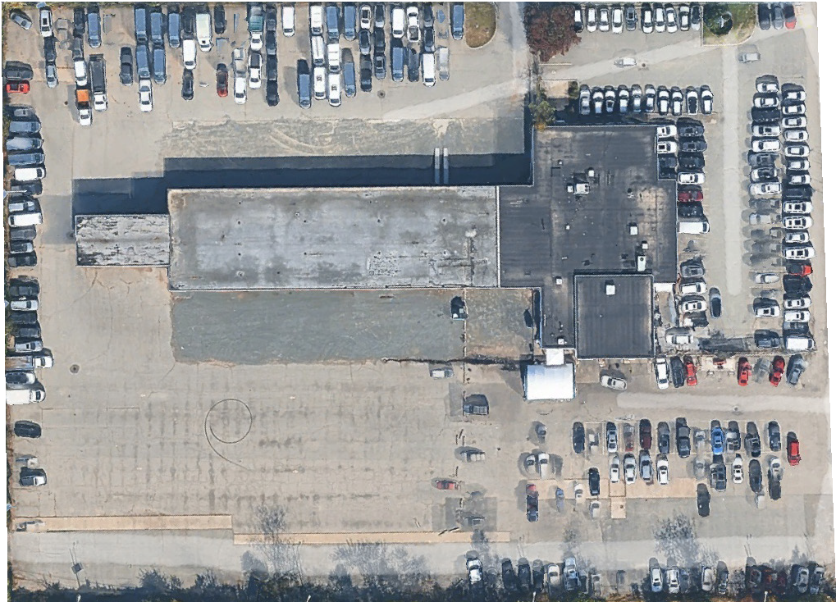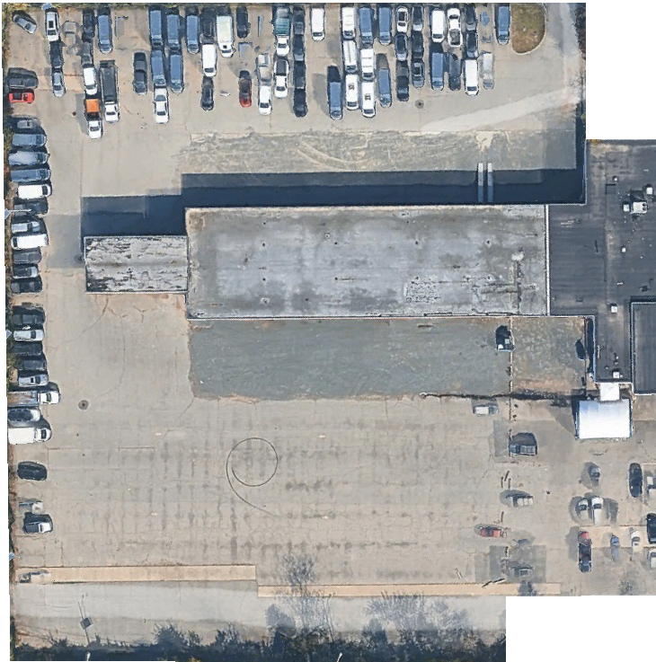
PROPOSED AQUISITION:
24 Andrews Drive - Woodland Park

